**From:** David Rolland   
**Subject:** **[Space Planning] Counting capacity details with capped positions**

**QUESTION:**

I have a question regarding the different position facings related fields we can use to clearly indicate the user how the capacity of a position is made of.

In the following example,

I have 1 facing WIDE, 8 facings DEPTH, 1 facing HIGH, 3 facings CAPPED in Height and 2 facings CAPPED in DEPTH.

But in the Position fields, I didn’t find any that specified the 2 facings CAPPED in DEPTH.

The total Capacity of this position considers all the units but I have to find a way to clearly explain the position scheme.

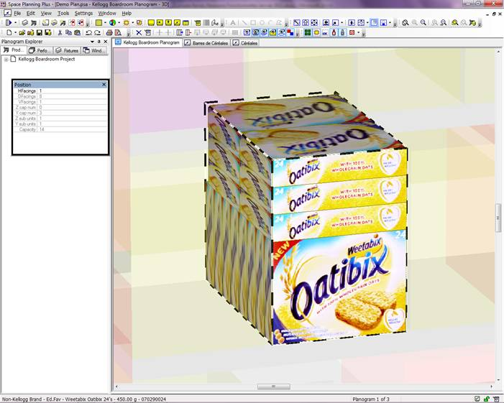

**ANSWER:**

Your screenshot does not display Depth capping (MerchZ), it represents Vertical capping (MerchY) that has enough space for the vertical caps to fill 2 units deep based on the depth of the position and the size & orientation of the vertical caps.  There are no fields that control how vertical caps fill deep separately from the settings that control the depth units of the main ‘upright’ facing.  Based on the depth of the position (which is controllable) we automatically fill units deep for the vertical caps.

You can report the Orientation of the vertical caps (Y cap orientation) and the number of vertical caps high (Y cap number), but we currently have no fields that would report “2” as the number of units that automatically fill deep for the vertical caps.   You might be able to design a formula that can calculate that using ‘Y cap orientation(Position)’ with the relevant product dimensions (based on Orientation), and how many of those capped orientations fits into ‘Depth(Position)’, but I haven’t tried that.

If your goal is to use a formula that can calculate the same Capacity that the merchandising engine within Space Planning calculates, then only under the most simplistic scenarios will this be possible.

There are dozens of complex calculations that not only considers the type of fixture and its merchandising volume (fixture depth, merchandising space (height or physical distance if no merchandising height defined), shelf overhangs, and shelf slope above or below), and how the product’s position is configured (merchandising style, number of facings and their orientation) and how the product’s position fits within the fixture's merchandising volume, but also capping (in up to 3 different directions), nesting, product overhangs (positive or negative), product finger space, dividers between facings, and fixture spread type (such as even facings). There may be obstructions that limit the merchandising volume of the fixture or the position's cubic volume, or maximum unit constraints (high, wide, deep) that can be set at the product, position, fixture, planogram or project level.  There is rounding that occurs when the position’s units do not fit exactly within the fixture's merchandising volume, and how well it does fit is affected by orientation, capping, etc.

The internal calculation consists of lots of complex programming code, which varies per fixture type, and which cannot be reproduced using the Formula Builder within Space Planning.  Space Planning uses a significant amount of code to run through all these calculations in order to determine how many units can fit into the merchandising volume.  It is a dynamic internal processing, and is just one example of why space management software is a very specialized application and not conducive to easy reproduction.

*Curtis*